|  |  |  |  |
| --- | --- | --- | --- |
| **INTERSTATE CONTAINER CORPORATION** | | ***Date:* 06/15/2018** | ***Spec #:*** |
| ***Customer:* DeMet's Candy** |  |  |  |
| ***Description:* Polyjoined HSC top - Turtles 6.4oz Bag - Update to Walmart 11" specification** | | |  |
| ***Style:* HSC** | ***Revision Info:* [0] 04/13/2018:+.25" L to R (AG 1/26/18)** | |  |
| ***I.D. :* 10+13/16 x 8+5/8 x 9** | ***Blank size:* 13+9/16 x 40+7/8** |  |  |
| ***Board:* 32 B W** | ***Combination:* 36MW - 23M - 35HP** | ***Designer:* Alan Groff** |  |

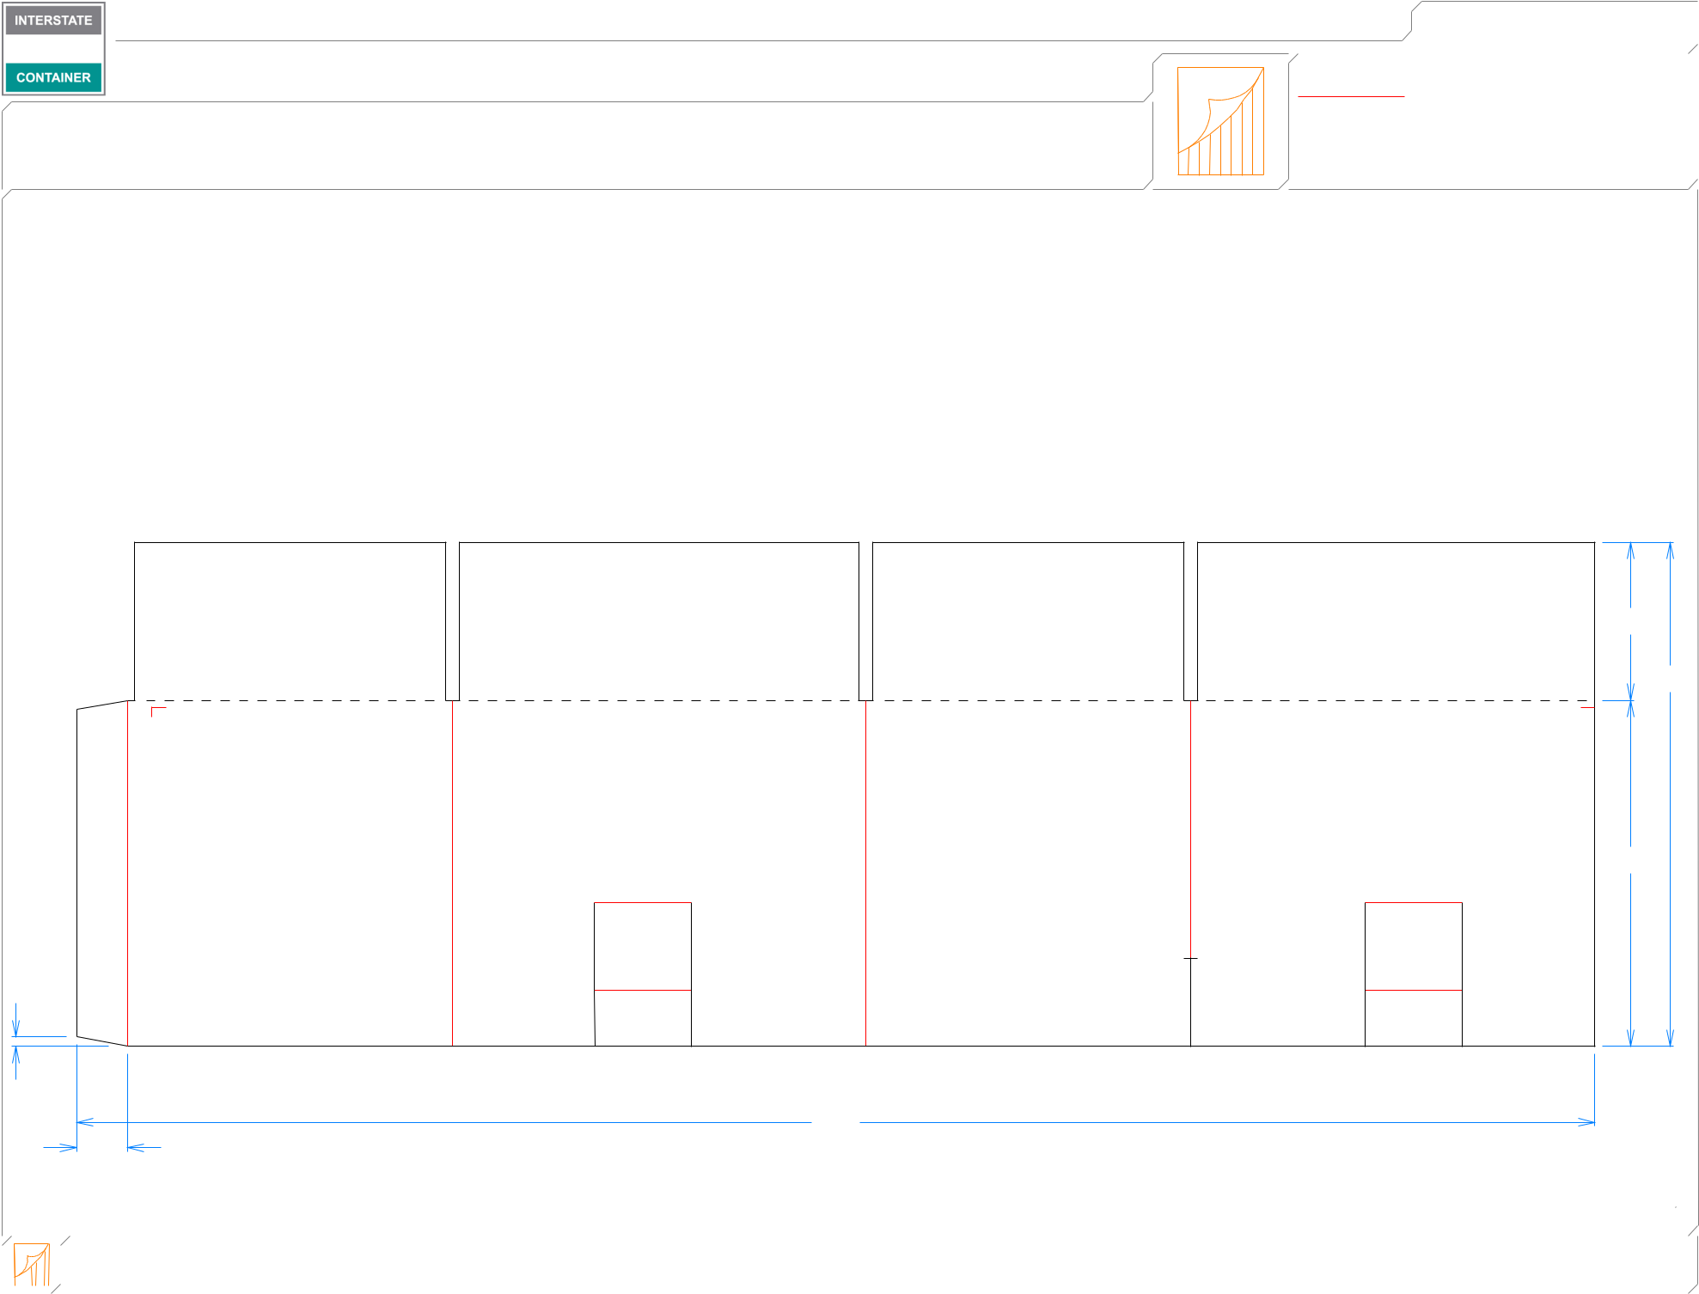

|  |  |  |  |  |  |  |  |  |  |  |  |  |  |  |  |
| --- | --- | --- | --- | --- | --- | --- | --- | --- | --- | --- | --- | --- | --- | --- | --- |
|  |  |  | ***Design #:*** | | | | | | | | | **180484-02** | |  |  |
|  |  |  |  |  |  |  |
|  |  |  |  |  |  |  |  |  |  |  |  |  |  |  |  |
|  |  |  |  |  |  |  |  |  |  |  |  | ***Cut*** | **153 in.** | |  |
|  |  |  |  |  |  |  |  |  |  |  |  |  |
|  |  |  |  |  |  |  |  |  |  |  |  | ***Crease*** | **46 in.** | |  |
|  |  |  |  |  |  |  |  |  |  |  |  | ***Partial cut*** | **1 in.** | |  |
|  |  |  |  |  |  |  |  |  |  |  |  |  |
|  |  |  |  |  |  |  |  |  |  |  |  | ***1/4 1/4 perf*** | **39 in.** | |  |
|  |  |  |  |  |  |  |  |  |  |  |  |  |
|  |  |  |  |  |  |  |  |  |  |  |  |  |  |  |  |

41*/*4

139*/*16

95*/*16

1*/*4

 83*/*4  111*/*8  83*/*4  107*/*8 

407*/*8

13*/*8

|  |  |  |  |  |  |  |  |  |  |  |  |
| --- | --- | --- | --- | --- | --- | --- | --- | --- | --- | --- | --- |
|  |  |  |  |  |  |  |  |  |  |  |  |
|  |  |  |  |  | **inside view** | | ***notes:* Polyjoined design** |  |  |  |  |
|  |  |  |  |  |  |  |  |  |
|  |  |  |  |  | **Vertical Corrugation** | | ***Qty/unit:*** | ***Area - waste:* 3.77 sq. ft** | ***Waste on blank:* 2.1%** | ***Piece weight - waste:* 0.39 lbs./177.96 g** |  |
|  |  |  |  |  |  |
|  |  |  |  |  |  |